Penne’ Pasta Salad

Smoked Wild Salmon and Asparagus
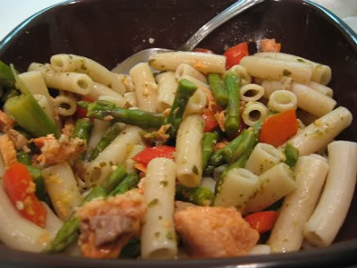
Preparation time: 45 minutes, but this pasta-salmon salad should be chilled for at least one hour before serving. This recipe serves 6-8 people depending on portion desired.

Ingredients:
- 6 tablespoons mayonnaise
- 1 1/2 tablespoons Dijon mustard
- 1 1/2 tablespoons sour cream
- 1 tablespoon fresh tarragon, chopped
- 1 tablespoon fresh lemon juice
- 1 tablespoon poppy seeds
- Salt and pepper to taste
- 2 cups Penne’ pasta
- Chopped tomato or halved cherry tomatoes (to taste) (optional)
- 1 1/2 pounds asparagus, ends trimmed, cut into one inch pieces (or green beans or snap peas)
- 1/2 cup green onions, thinly sliced
- 8 ounces wild smoked salmon

Instructions:
- Whisk first 6 ingredients in a medium bowl and season with salt and pepper
- Cook pasta in large pot of boiling, salted water until pasta is almost tender but still firm to bite (al dente’- follow package directions)
- Drain, but reserve 1/4 cup cooking liquid
- Rinse pasta with cold water until cool and drain well in colander
- While pasta is cooking, cook asparagus in a small amount of water in a skillet (or better yet, steam it) for about 1 minute in a steamer pan or basket
- Drain asparagus and transfer to large bowl with the pasta
- Add green onions and smoked salmon
- Mix the reserved cooking liquid into the dressing
- Add to salad and toss to blend
- Season with salt and pepper and transfer to serving bowl and
Chill at least one hour and up to six hours for best flavor results

